**STATICS** ***UDM ENGR 3120*** - ***BUCT MEC 1701-1703*** ***CHAPTER 2 – Statics of Particles***

ASSIGNMENT # 1-1 Due on 9/12/19 Student # ………………. Name …………………………

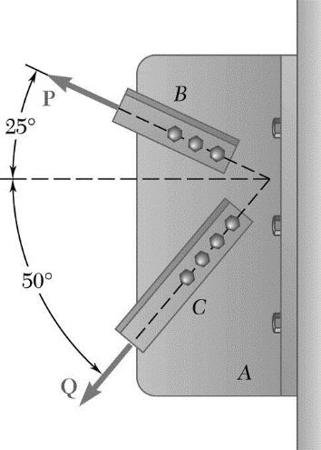

Two structural members *B* and *C* are bolted to bracket *A*. Knowing that both members are in tension and that

*P* = 10 kN and *Q* = 15 kN

Determine the magnitude and direction of the resultant force exerted on the bracket, using

(*a*) the parallelogram law

(*b*) the triangle rule

(c) graphical method